“Data visualisation has become an essential business capability to help transform information into insights that can drive meaningful business outcomes and improved experiences. Today, most organisations have accumulated a wealth of data from different corners of their businesses that they are unable to see how this data can help them make better decisions, making actions and results. You have been asked to look at the data workbook and familiarise yourself with this data. You have also been asked to create a visual report that will show the data in the form of charts and maps using Tableau to the clients’ requirements. You will also need to consider data protection and computer misuse policies.”

Arun Asokan

Data Visualisation

Assignment 1

24/01/2023

Contents

**First Task** 2

**Policies and Procedures** 2

**Second task** 3

**Excel** 3

**Third Task** 18

**Tableau** 18

**Client Requirements** 21

# **First Task**

## **Policies and Procedures**

When working with data, it is critical to adhere to data protection and privacy laws, such as the General Data Protection Regulation (GDPR) in the EU and the California Consumer Privacy Act (CCPA) in the US. This includes obtaining informed consent from individuals before collecting, storing, and using their data, and ensuring that personal information is kept secure and not shared without permission. Additionally, it is essential to be transparent about data collection and usage, and to provide individuals with the ability to access and control their own data. It is also imperative to ensure data accuracy and integrity, and to handle any errors or inaccuracies in a timely manner.

When working with data, several policies need to be adhered to including:

1. **Data Privacy:** Ensuring that personal and sensitive information is protected and not shared without proper consent.
2. **Data Security:** Implementing measures to protect data from unauthorised access, use, disclosure, disruption, modification, or destruction.
3. **Data Governance:** Establishing guidelines and protocols for how data is collected, stored, used, and shared within an organization.
4. **Data Quality:** Data should be accurate, complete, and up to date. This includes ensuring that data is free from errors and bias, and that it is regularly reviewed and updated as needed.
5. **Compliance:** Adhering to relevant laws and regulations related to data, such as the General Data Protection Regulation (GDPR) and the Health Insurance Portability and Accountability Act (HIPAA).
6. **Ethical Considerations:** Ensure that your data usage respects human rights and dignity, avoids discrimination, and consider the potential impacts of your work on different groups.
7. **Data Retention:** Having a policy in place for how long data is retained and when it is deleted or archived.
8. **Data Accessibility:** Data should be accessible to authorised individuals and systems, and in a format that is usable and actionable.

Adhering to data protection policies is important because it ensures the security and privacy of personal and sensitive information. These policies outline how data should be collected, stored, and used, and they help prevent data breaches, unauthorised access, and misuse of information. Failure to comply with these policies can lead to legal penalties, financial losses, and damage to an organisation's reputation. Additionally, it can also lead to violation of individual's right to privacy and personal data which can lead to loss of trust and legal action. Overall, adhering to data protection policies is vital for maintaining the integrity and confidentiality of data, protecting individuals and organisations from harm, and complying with legal and regulatory requirements.

# **Second task**

## **Excel**

1. **Set a password to protect the workbook**

Click ‘File’, then select ‘Info’, choose the option ‘Protect Workbook’.

Select ‘Encrypt with Password’ and choose a password to protect the workbook.

1. **Highlight column C and change the data to display in British Pound symbol**

Click on ‘C’ to highlight the entire column C.

Right click and select ‘Format Cells’.

Select ‘Number’ and choose ‘Accounting’. Ensure the Symbol selected is ‘£’.

1. **Turn the GDP sheet into a table**

Click anywhere on the data and then click the tab ‘Insert’ and then on ‘Table’.

This will bring up the below, ensure the tick box is ticked if there are any headers in the data.

This will then put the data in to a table format as shown below.

1. **Filter the table to display only the information for 2019**

Highlight the headers for which you are wanting to add a filter for. Select the ‘Home’ tab and then ‘Sort and Filter’ and click ‘Filter’.

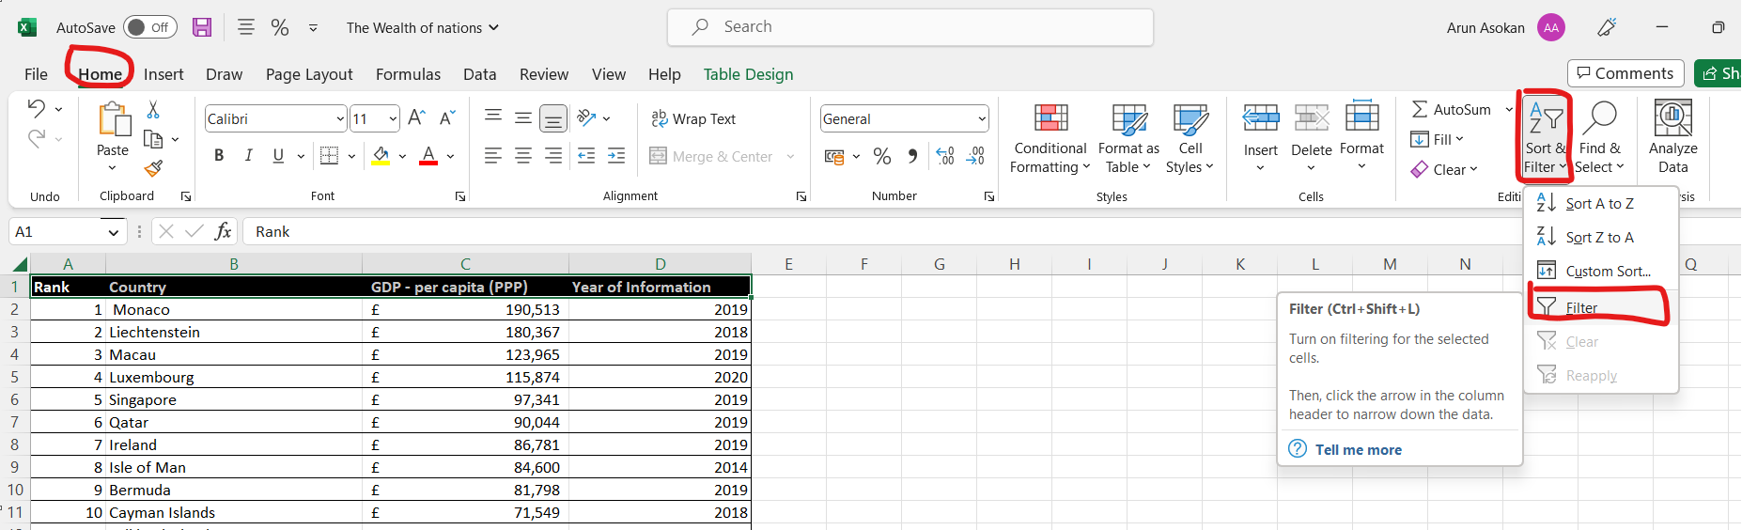

Once the filters have been added, click the drop-down box on ‘Year of Information’, untick the ‘Select All’ and tick ‘2019’.

This will filter the data to display information only for 2019.

1. **Next create a chart that will only display the following data Rank, Country, and GDP - per capita (PPP). The chart can be anything if it is suitable.**

Highlight ‘Rank’, ‘Country’ and ‘GDP’ by selecting and dragging your mouse over column A, B and C. Click the ‘Insert’ tab and then on ‘Recommended Charts’ or any chart of your choice.

Choose an appropriate chart and select ‘OK’.

This will the create a chart as detailed below.

1. **Using your creative skills edit the chart** 
   1. **Add a title**
   2. **Add X and Y axis labels**
   3. **Make the chart visually pleasing**

Click on the created chart and then select the tab ‘Chart Design’. Once chosen, pick the option ‘Add Chart Element’ and then ‘Chart Title’. From here you can choose where to create the title and choose an appropriate title for the chart, as highlighted in yellow.

Click on the created chart and then select the tab ‘Chart Design’. Once chosen, pick the option ‘Add Chart Element’ and then ‘Axis Title’. From here you can choose where to create the axis title and choose an appropriate title for the axis.

This will create the below chart with the axis labelled. By clicking on ‘Chart Design’ and ‘Format’ you can change the colour, text style, shape fill etc and create a chart which is visually pleasing.

1. **Move the chart to a new sheet tab and label with a suitable name**

Click the ‘Plus’ button at the bottom of the excel worksheet. This will create a new worksheet and then rename it to an appropriate name.

1. **Create a sort for the top 20 highest ranking counties**

Click on the drop-down box from ‘Rank’ and select the option ‘Sort Smallest to Largest’. This will order the table from the Rank category starting with the smallest value, i.e. 1, 2, 3… etc.

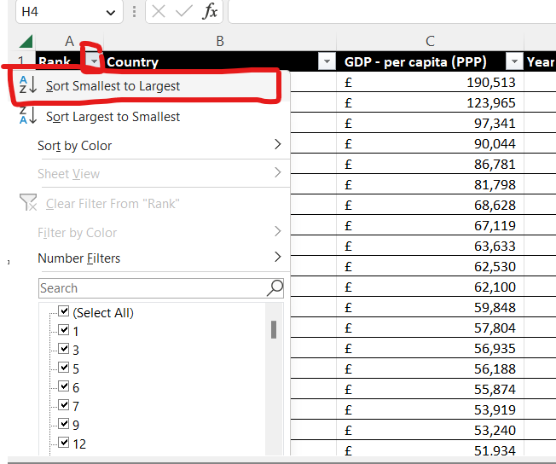

Click on the drop-down box from ‘Rank’ and select the option ‘Number Filters’. From here select the option ‘Between’.

This will bring up the below box. From here ensure the parameters are correct ( is >= 1 and <=20 in this case) and then click ‘OK’.

This will then create a table sorted by rank from 1 to 20 as detailed below.

1. **Next create a new Bar chart to display the 20 highest ranking countries from your sort and then move the chart to be underneath the table, as shown below.**

Create a bar chart as detailed on point 5. Drag and drop the chart below the table as instructed.

1. **Colour the background by highlighting the area underneath the table as shown below. Find the add a fill colour icon and sellect a colour.**

Highlight the area underneath the table, click on the circled icon and this will fill the area with colour as detailed below.

1. **The next task is to create 3 macro buttons, print the sheet, Save the file and Copy the sheet.**

Click the tab ‘View’ and then select ‘Macros’ and finally ‘Record Macros’.

Next give your Macro a name, a shortcut key (if you wish) and a brief description then click ‘OK’.

Highlight the area you are wanting to copy, right click and select ‘Copy’.

Once that has been completed, click ‘View’ and choose the option ‘Macro’ and click ‘Stop Recording’.

From here choose the ‘Developer’ tab (this needs to be unhidden from Excel, you can do this by selecting ‘File’, ‘Options’, ‘Customise Ribbons’ and tick the box ‘Developer’ from the right hand side table). Click ‘Insert’ and then ‘Button’ ensuring the area for which the Macro is being applied has been highlighted.

The following box will open, select the Macro name which is relevant and click ‘OK’.

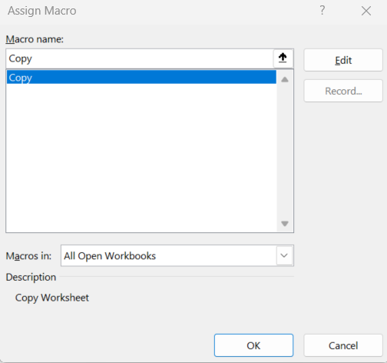

Then the below copy button will be created.

Follow the same process to create Macro buttons for ‘Save’ and ‘Paste’.

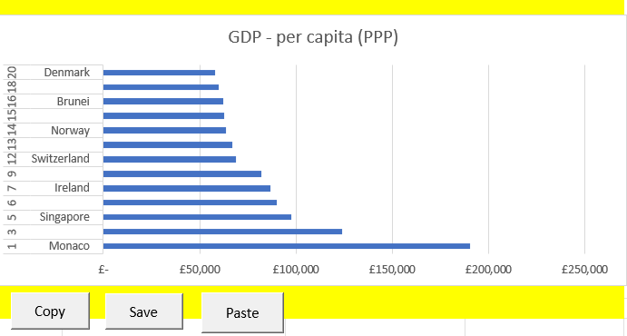

1. **Using the copy macro, copy the sheet and then paste it into a new word document keeping the formating. Give the page a title ‘GDP (****Gross domestic product)’ .**

Click the ‘Copy’ macro and paste in to a word document, giving the requested title as detailed below.

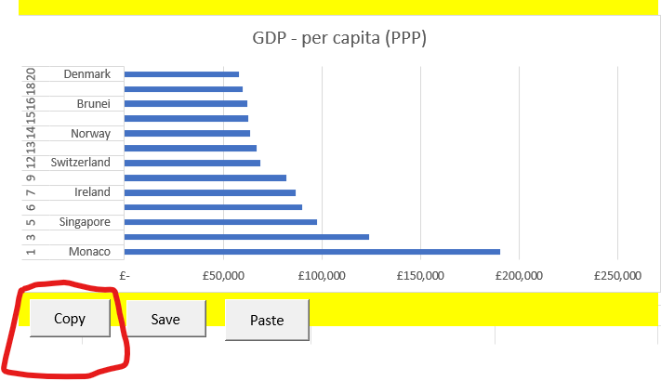

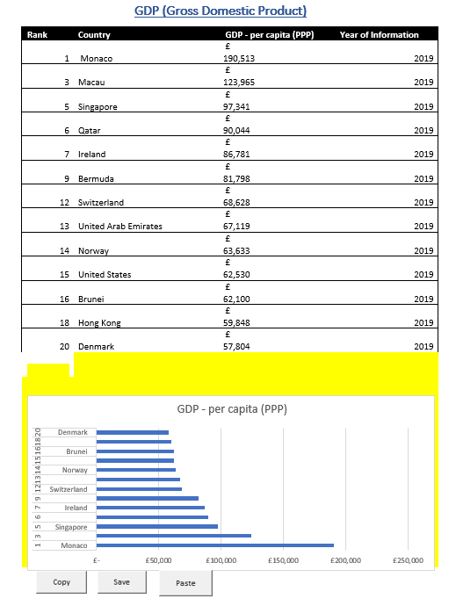

1. **Save your document as ‘Word Gross domestic product report 1’**

Click ‘File’ and ‘Save As’. Save the file using the requested document title.

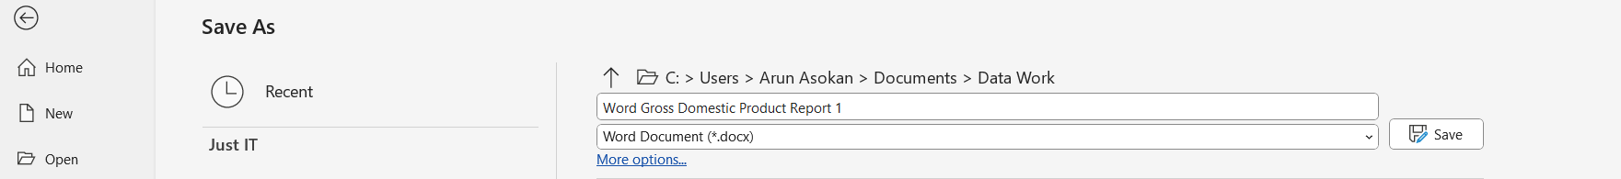

1. **Before we finish with our excel table ‘Gross domestic product’ sheet, we will add a header and footer to our table.**

Click ‘View’ and select ‘Page Layout’

1. **In the header enter your name and GLA DATA 1 in the three boxes**

1. **In the footer add todays date then Assignment 1 and lastly Data Visualisation**

1. **Return your view to normal**

From the ‘View’ tab select ‘Normal’.

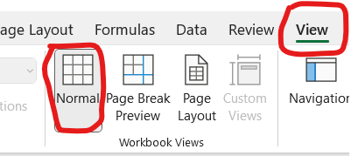

1. **Save your table as ‘Excel Gross domestic product report 1’**

Click ‘File’ and ‘Save As’. Save the file using the requested document title.



# **Third Task**

## **Tableau**

1. **Import data**

Under the section ‘Connect’ click on the option ‘Microsoft Excel’ to import the data from Excel.

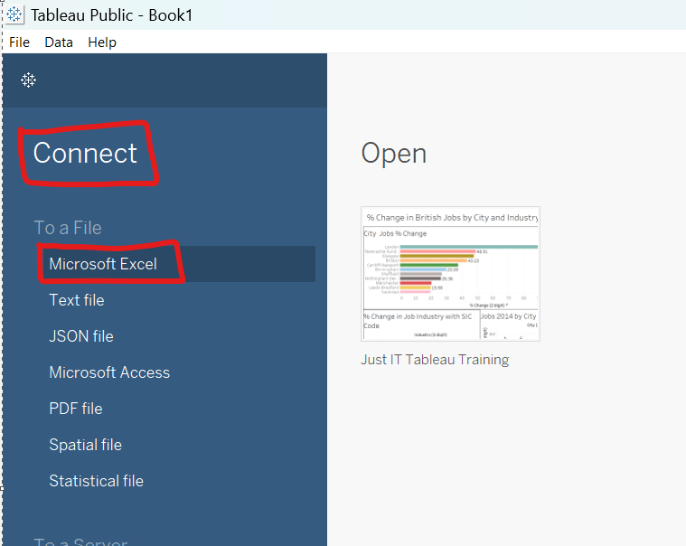

This will bring up the below on completion of successful import.

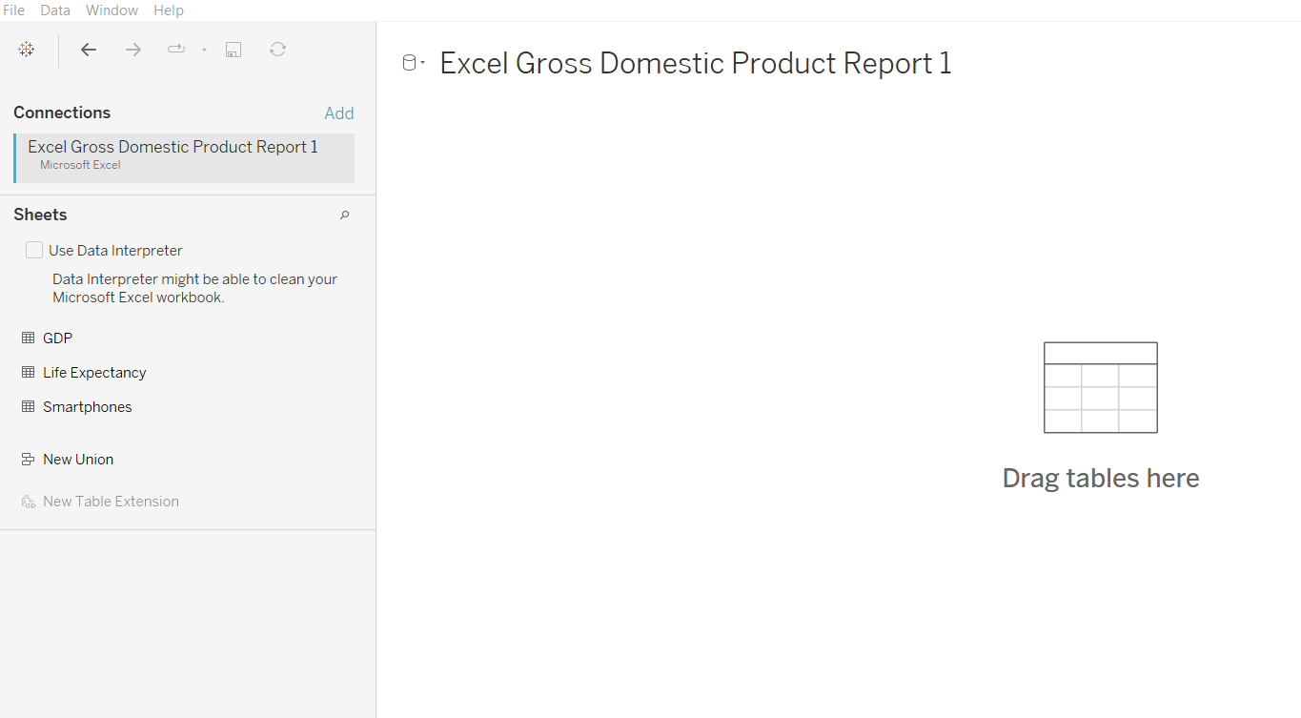

1. **Set relationships**

Set relationships by dragging and dropping the relevant sheets (from the left-hand side) into the designated space as circled below. Ensure the relationships/ joins for the sheets have a common column, in this case it will be ‘Country’.

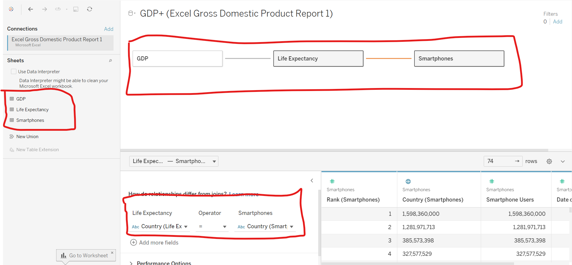

1. **Check data types**

Make the sure the data types are correct by clicking the below circled icon. This will bring up the data options as seen below.

1. **Build charts**

Once data types have been set you are ready to create visuals. Go to the bottom of the screen and you will see the below, click on the highlighted ‘Sheet 1’.

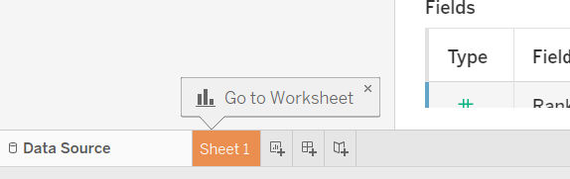

Drag and drop the relevant fields in to the Columns and rows. You can change the chart type by clicking on the drop down box below ‘Marks’.

If you are unsure as to what chart would be suitable, click the ‘Show Me’ button on the top right hand side of the screen. This will recommend charts and give you a brief description of the fields required.

Below are some examples of charts/ visualisations created.

## **Client Requirements**

The client is colour blind and requested you to bear this in mind when building your dashboard. The client is only interested in the top 20 highest ranking countries. All your visuals should be for the top 20 highest ranking countries.

